Assignment 2.3

and

Assignment 2.4

Report

COHDSE182f006 – S. M. Lagamuwa

Index.php file

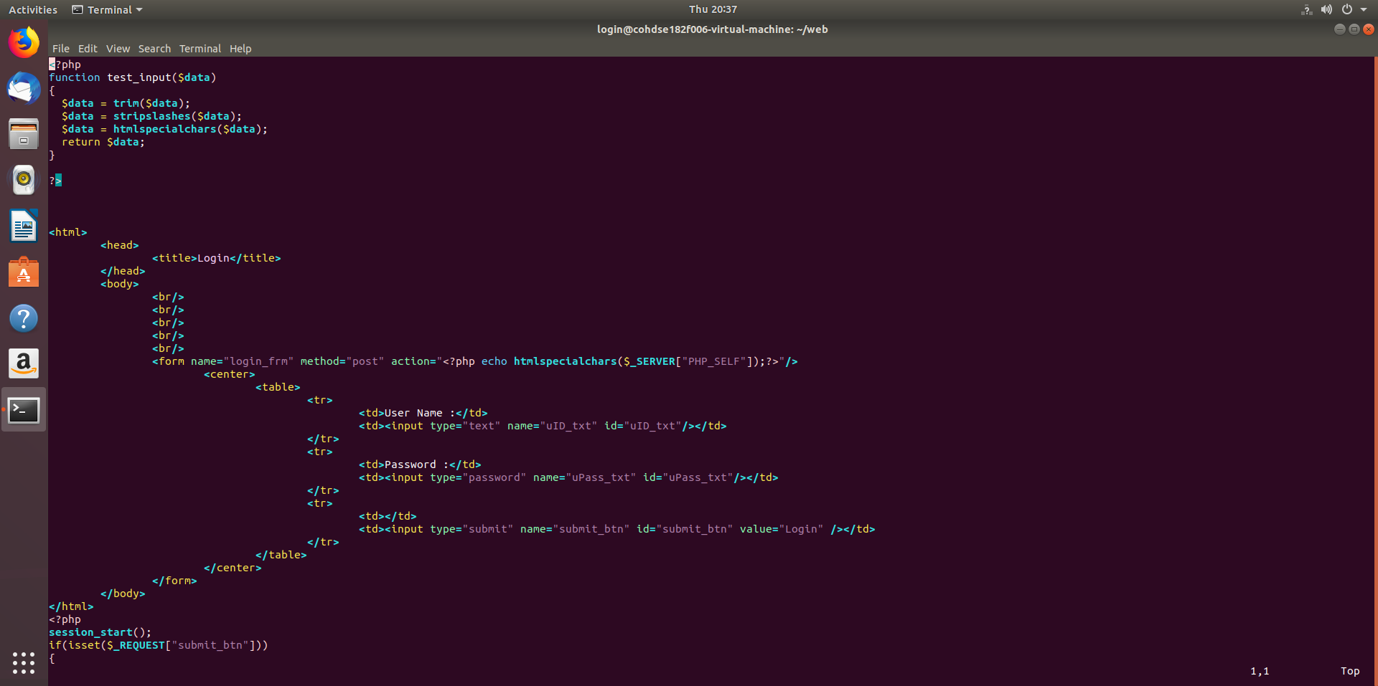

A function named ‘test_input’ is defined to trim , strip slashes and convert html special chars into unharmful characters.

This function is used to pass through user input and remove harmful elements in user input.

Htmlspecialchars in built method is used in the form action to disallow the user of sql injections through the url.

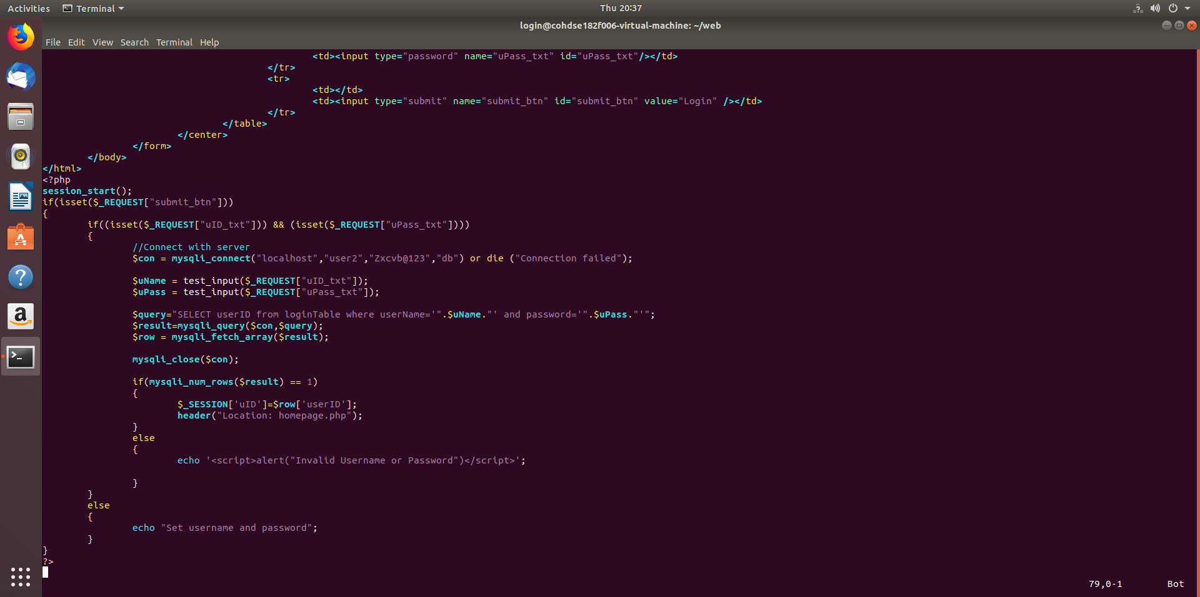

Select query is returning only a userID to ensure security.

Uses a session variable to pass userID to the next form.

Homepage.php file

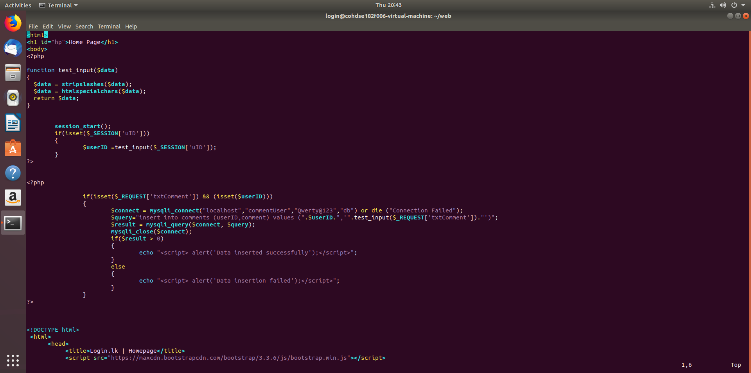

Sets userID into a php variable.

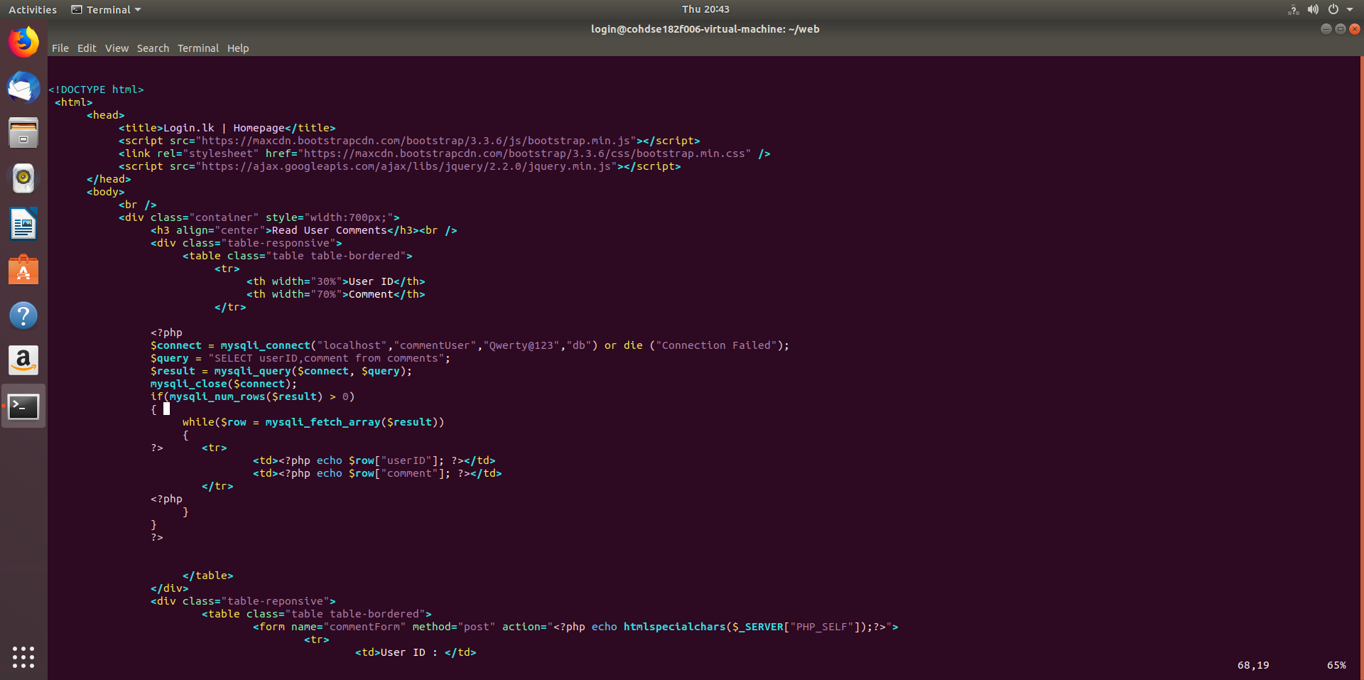

Uses a different mysql user who is with access to only the required ‘Comments’ table.

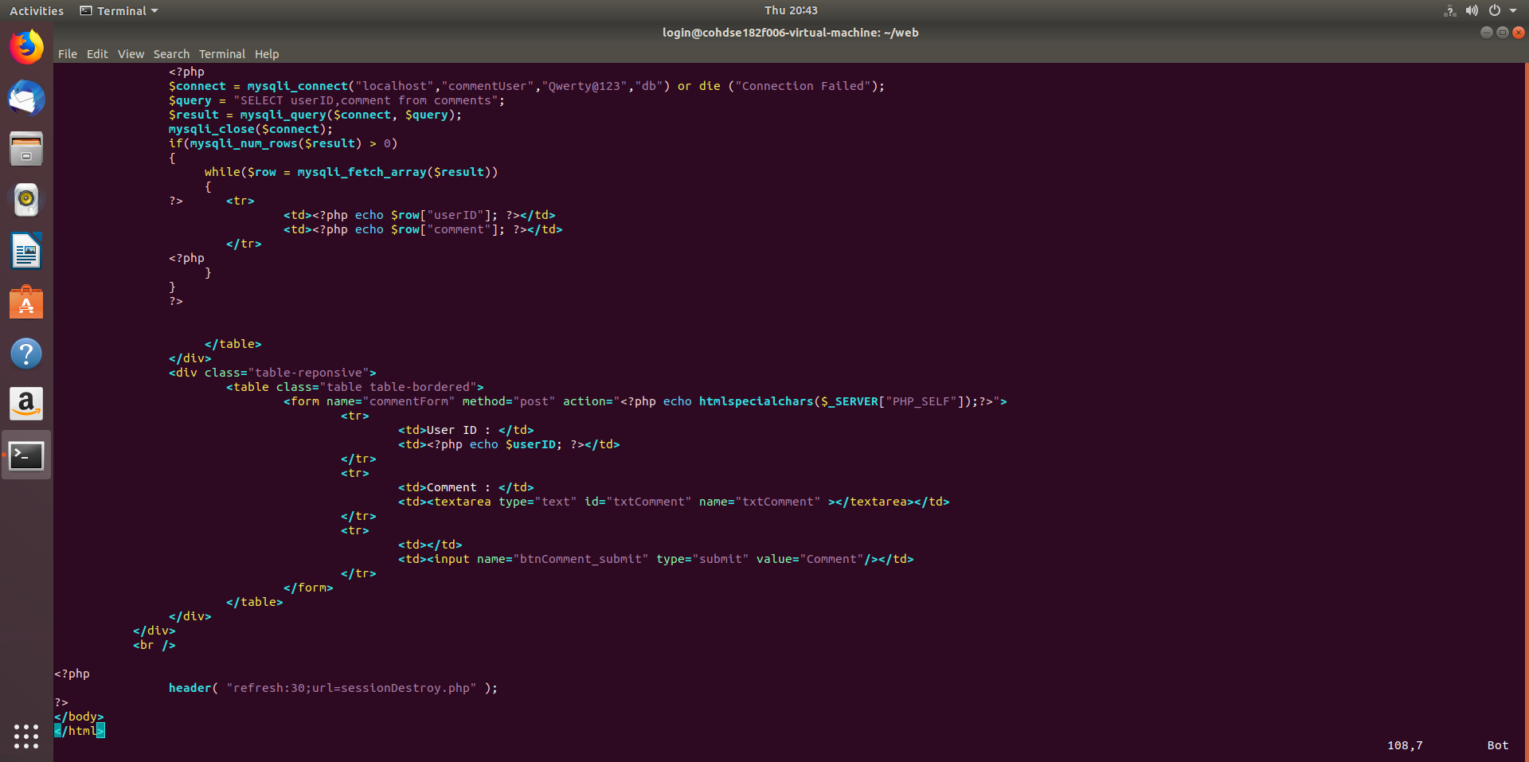

If the page stays idle for 30 seconds without a refresh, the page redirects to sessionDestroy.php file

sessionDestroy.php file

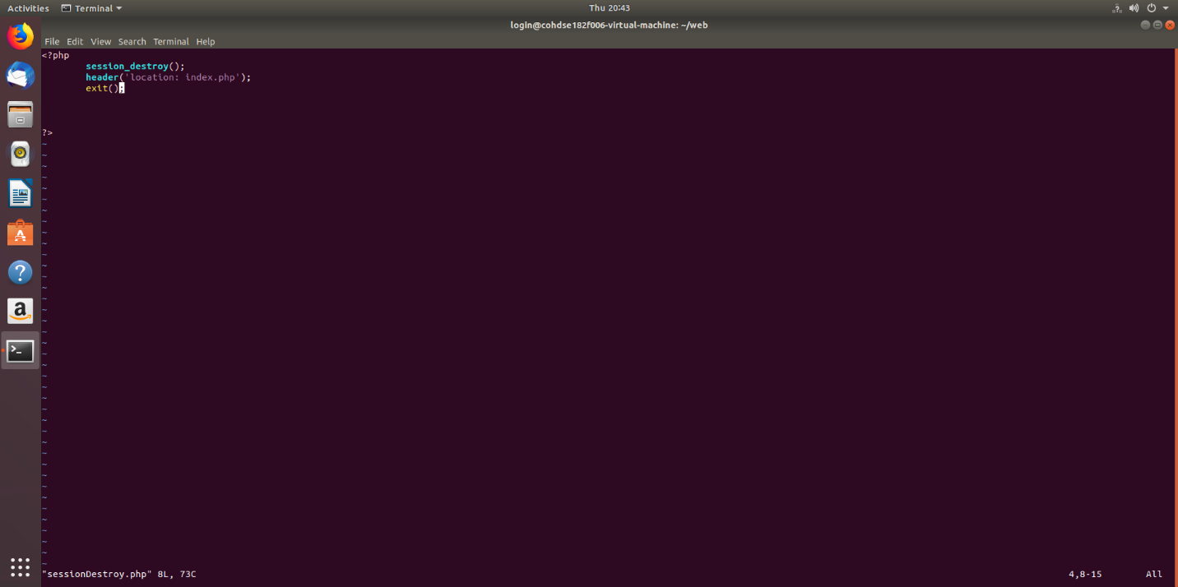

Destroy session variables and redirects to the index.php file

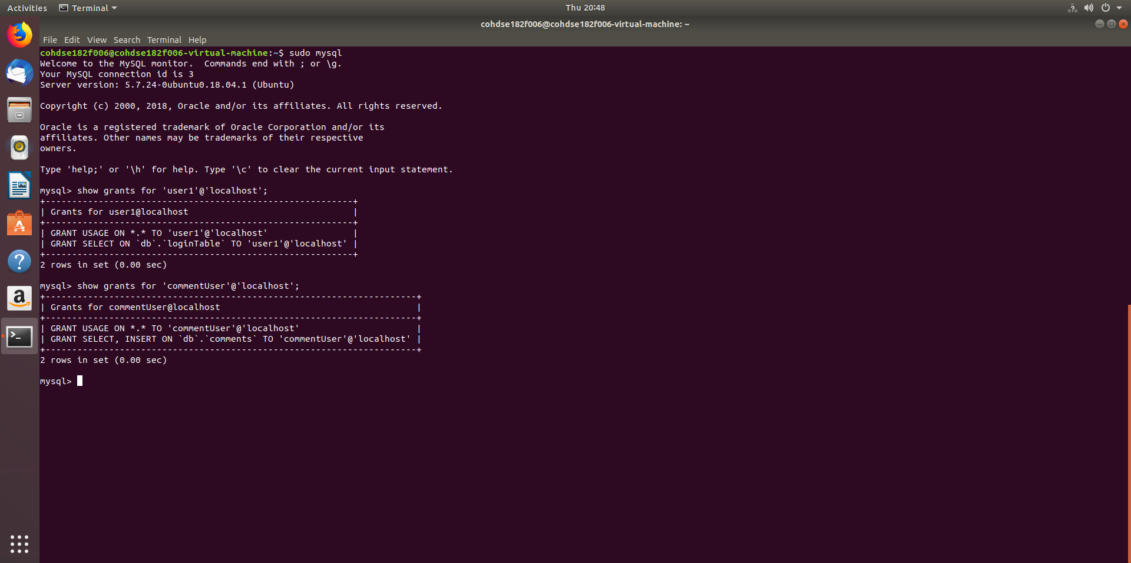

Mysql privileges allowed to the two users.

